**Statistical Test**

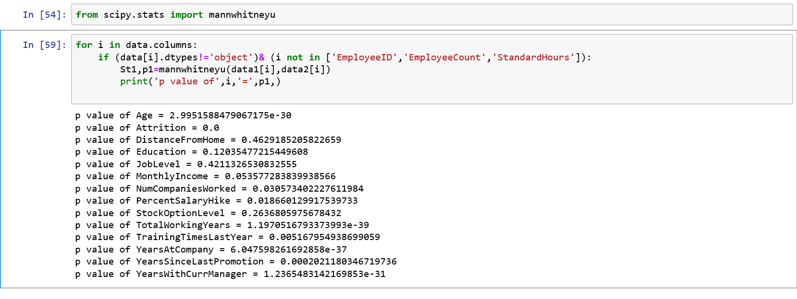

**Group-1: Attrition=Yes Group-2: Attrition=No**

**Hypothesis 1: Age**

Null Hypothesis, Ho = There is no significant difference in Age for Group-1 and Group-2

Alternate Hypothesis, H1 = There is significant difference in Age for Group-1 and Group-2

As p-value < 0.05, so we **reject** null hypothesis and **accept** Alternate Hypothesis.

**Hypothesis 2: Distance from home**

Null Hypothesis, Ho = There is no significant difference in Distance from home for Group-1 and Group-2

Alternate Hypothesis, H1 = There is significant difference in Distance from home for Group-1 and Group-2

As p-value > 0.05, so we **accept** null hypothesis and **reject** Alternate Hypothesis.

**Hypothesis 3: Education**

Null Hypothesis, Ho = There is no significant difference in Education for Group-1 and Group-2

Alternate Hypothesis, H1 = There is significant difference in Education for Group-1 and Group-2

As p-value > 0.05, so we **accept** null hypothesis and **reject** Alternate Hypothesis.

**Hypothesis 4: Job level**

Null Hypothesis, Ho = There is no significant difference in Job level for Group-1 and Group-2

Alternate Hypothesis, H1 = There is significant difference in Job level for Group-1 and Group-2

As p-value > 0.05, so we **accept** null hypothesis and **reject** Alternate Hypothesis.

**Hypothesis 5: Monthly Income**

Null Hypothesis, Ho = There is no significant difference in Monthly Income for Group-1 and Group-2

Alternate Hypothesis, H1 = There is significant difference in Monthly Income for Group-1 and Group-2

As p-value >0.05, so we **accept** null hypothesis and **reject** Alternate Hypothesis.

**Hypothesis 6: Number of companies worked**

Null Hypothesis, Ho = There is no significant difference in Number of Companies worked for Group-1 and Group-2

Alternate Hypothesis, H1 = There is significant difference in Number of Companies worked for Group-1 and Group-2

As p-value < 0.05, so we **reject** null hypothesis and **accept** Alternate Hypothesis.

**Hypothesis 7: Percent Salary hike**

Null Hypothesis, Ho = There is no significant difference in Percent Salary hike for Group-1 and Group-2

Alternate Hypothesis, H1 = There is significant difference in Percent Salary hike for Group-1 and Group-2

As p-value < 0.05, so we **reject** null hypothesis and **accept** Alternate Hypothesis.

**Hypothesis 8: Stock Option Level**

Null Hypothesis, Ho = There is no significant difference in Stock Option level for Group-1 and Group-2

Alternate Hypothesis, H1 = There is significant difference in Stock Option level for Group-1 and Group-2

As p-value >0.05, so we **accept** null hypothesis and **reject** Alternate Hypothesis.

**Hypothesis 9: Total Working Years**

Null Hypothesis, Ho = There is no significant difference in Total Working Years for Group-1 and Group-2

Alternate Hypothesis, H1 = There is significant difference in Total Working Years for Group-1 and Group-2

As p-value < 0.05, so we **reject** null hypothesis and **accept** Alternate Hypothesis.

**Hypothesis 10: Training time last year**

Null Hypothesis, Ho = There is no significant difference in Training time last year for Group-1 and Group-2

Alternate Hypothesis, H1 = There is significant difference in Training time last year for Group-1 and Group-2

As p-value >0.05, so we **accept** null hypothesis and **reject** Alternate Hypothesis.

**Hypothesis 11: Years at Company**

Null Hypothesis, Ho = There is no significant difference in Years at Company for Group-1 and Group-2

Alternate Hypothesis, H1 = There is significant difference in Years at Company for Group-1 and Group-2

As p-value < 0.05, so we **reject** null hypothesis and **accept** Alternate Hypothesis.

**Hypothesis 12: Years since last promotion**

Null Hypothesis, Ho = There is no significant difference in Years since last promotion for Group-1 and Group-2

Alternate Hypothesis, H1 = There is significant difference in Years since last promotion for Group-1 and Group-2

As p-value < 0.05, so we **reject** null hypothesis and **accept** Alternate Hypothesis.

**Hypothesis 13: Years with current manager**

Null Hypothesis, Ho = There is no significant difference in Years with current manager for Group-1 and Group-2

Alternate Hypothesis, H1 = There is significant difference in Years with current manager for Group-1 and Group-2

As p-value < 0.05, so we **reject** null hypothesis and **accept** Alternate Hypothesis.